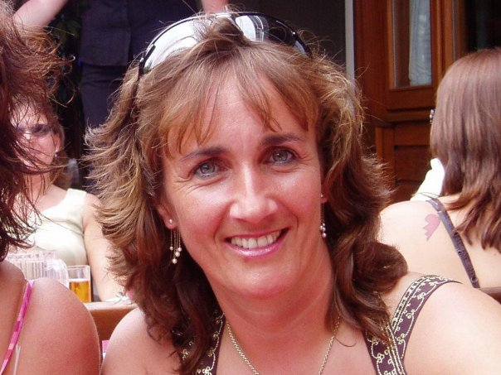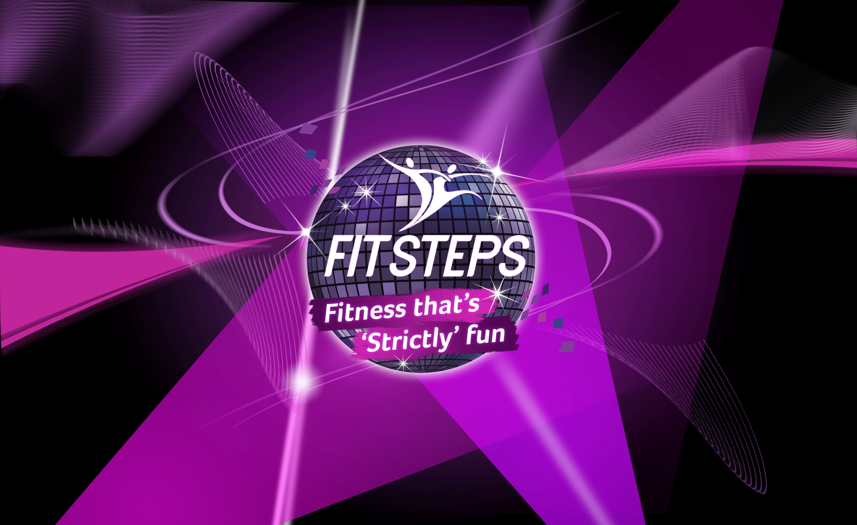

***Booking advisable!***

Wednesday 6pm Together with Donna & Vanessa

**EXCITING BALLROOM/LATINDANCE FITNESS**

Thursday 6pm

Saturday 10am

St Saviours Community Centre

£7 drop-in

Loyalty Card £60 = 10 +1 FREE

**FitSteps has been created by “Strictly” Ian Waite & Natalie Lowe alongside Olympic swimmer Mark Foster.**

**“Balancing Fitness for Life!” with Donna**

**07781 165358**

**www.thebodystudioguernsey.com**

**Monday 6.30pm Les Adams Methodist Hall**

**Wednesday 6pm**

**Sylvans FC**

**£7 drop-in**

**Loyalty Card £60 = 10 + 1 FREE**

**“Walk In, Dance Out” with Vanessa**

**07781 123486 www.danceographyguernsey.com**